Ideation Phase
Brainstorm & Idea Prioritization Template

Date | 30/10/2025
Team ID | NM2025TMID05890
Project Name | Calculating Family Expenses using Service Now
Maximum Marks | 4 Marks

Calculation Family Expense Using ServiceNow temple:
Managing household expenses can be challenging for families, with manual methods often leading to errors, inefficiencies, and a lack of actionable insights. The aim of this project is to design and implement a Family Expense Management System using ServiceNow—a robust workflow automation platform—to streamline and automate the tracking, analysis, and reporting of daily and monthly family expenses.​
In this project, ServiceNow will be configured to allow users to quickly log expenses under relevant categories (such as groceries, rent, utilities, and education) through intuitive forms and automated workflows. The system will provide visual dashboards summarizing total and category-wise spending, generate downloadable reports, and send alerts when budgets are exceeded. By leveraging ServiceNow’s automation capabilities, families will gain improved financial oversight, including real-time insights and proactive budgeting support.​
This project not only brings digital transformation to personal finance management but also showcases ServiceNow’s versatility beyond its traditional IT use cases, highlighting its potential as a low-code/no-code platform for practical, real-world applications.

Step-1: Team Gathering, Collaboration, and Select the Problem Statement
The family expense management project begins by assembling a collaborative team of family members and ServiceNow experts. The primary aim is to tackle the problem many families face: difficulties in accurately tracking and categorizing daily expenses, which leads to ineffective budgeting and poor financial oversight. Through open discussion, the team aligns around a clear problem statement—designing a ServiceNow solution to automate and streamline the calculation and reporting of family expenses

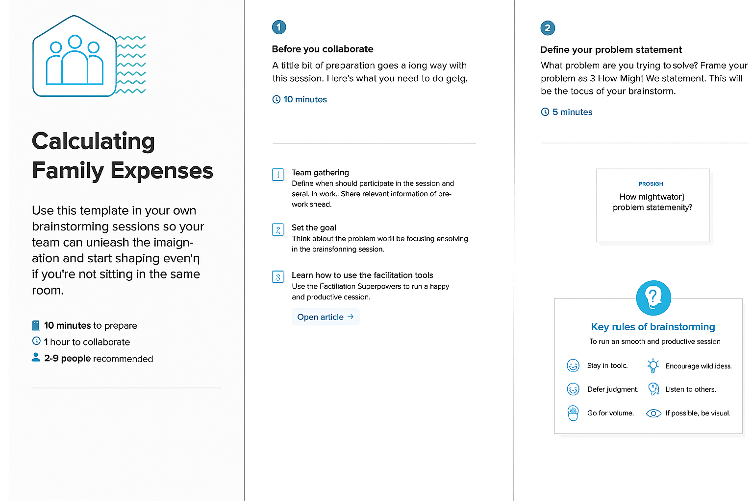

Step-2: Brainstorm, Idea Listing & Grouping
Idea Listing
- Log daily expenses in ServiceNow with an intuitive, easy-to-use entry form.​
  - Teammate builds: Add categorization for expense types such as groceries, rent, utilities, and more.​
- Automatically generate monthly and weekly family expense reports.​
  - Teammate builds: Incorporate visualizations to track spending trends and patterns.
- Set up automated budget alerts when expenditures approach or exceed preset limits.​
  - Teammate builds: Notify family members individually through email or mobile notifications.
- Use ServiceNow’s service catalog for submitting, viewing, and approving expense entries.
  - Teammate builds: Implement role-based access, giving parents and children tailored views.
- Create an interactive dashboard for real-time expense insights.​
  - Teammate builds: Provide savings tips based on analyzed family spending behavior.
Grouping
Ideas are grouped into four categories:
- Data Entry & Validation
- Reporting & Visualization
- Automated Alerts
- User Experience & Accessibility

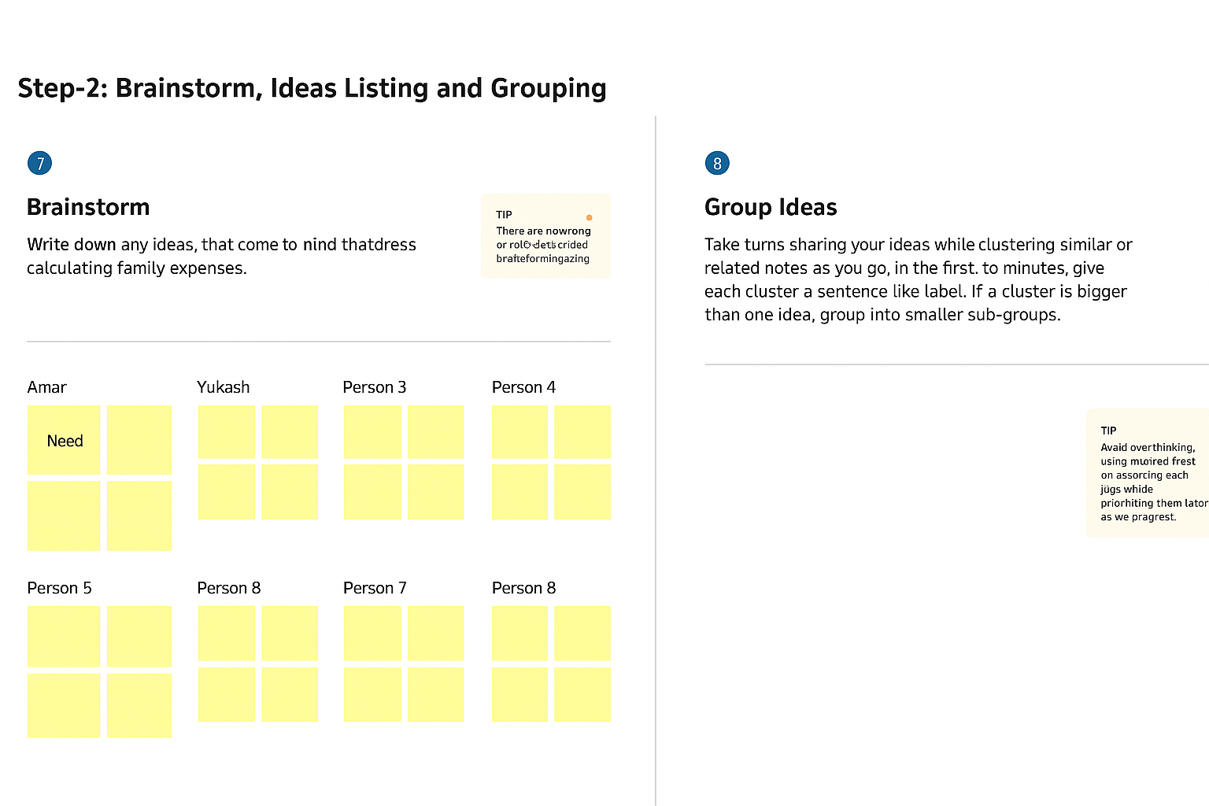
Step 3: Idea Prioritization
- Prioritize ideas based on impact, technical complexity, and user value.​
- Example matrix:

Idea | Impact | Complexity | Priority
Log daily expenses | High | Low | 1
Generate reports & trends | High | Medium | 2
Setup budget alerts | Medium | Medium | 3
Role-based dashboards | Medium | Medium | 4
Service catalog integration | Low | High | 5

Action Planning
- Assign responsibilities and create timelines for implementing top ideas.

